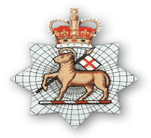
Surrey Infantry
Museum
Museum Newsletter – April 2020 Volume1 Issue 18

Oct 2011
Volume 1 Issue 1

AIM
To maintain knowledge within the County of Surrey’s Infantry Regiments from 1661 to the present Day

FOSIM – Tony Ward
FOSIM NEWSLETTER APRIL 2020
I hope you are all well and keeping safe from this virus. Having to Self-Isolate has forced me to find time to read, but not being able to go to bookshops; I have been forced to re-read those on my bookshelves. I have just finished FM Slim’s “Defeat into Victory”. It is without doubt the very best instruction of both Leadership and Command I have read. It tells the story of The “Forgotten Army” in what was then Burma now Myanmar. Throughout the book he heaps praise on his boss - during the difficult times – General George Giffard who was a Queensman and whose banner hangs in the Regimental Chapel in Guildford Cathedral. I wonder if history has not fully recognised his contribution to the Far East Campaign. He was Colonel of The Queen’s Royal Regiment 1945 -1954. I followed up reading FM Slim’s book by re-reading Lt Col Mike Lowry’s “Fighting through to Kohima” account of B Coy,1 Queen’s in the North West Frontier and then Arakan and relief of Kohima. During this battle the Battalion lost 69 killed and 124 wounded. Gosh, those in the Far East had a hard war with many not being able to get home for over 5 years, someone even longer.
I next went on to thinking about VE and VJ Day 75th Anniversaries which are coming up. I strongly recommend you go to The Queen’s Surreys website “Buried Battles and Veterans Voices” http://www.queensroyalsurreys.org.uk/video/index.shtml in which our Regimental forbearers tell their stories. I was particularly moved hearing CSM Jolley and Sgt Martin of 2rd East Surreys talking about their time as Japanese POW’s. The stories of those who were forced to surrender at Dunkirk and spent 4 ½ long years a German POW’s are equally moving.
Perhaps it is worth reminding ourselves of the Surrey Regiment’s deployments and action between 1939 and 1945.
The 1st Battalion Queen's Royal (West Surrey) Regiment continued to serve in India against tribesmen on the North-West Frontier at the start of the Second World War. The Battalion then transferred to Burma and saw a great deal of hard fighting against the Japanese in the Arakan, at Kohima and in the Irrawaddy operations. After the Japanese surrender, the 1st Battalion spent a short period in Malaya, before returning home.

Inside This Issue
1 FOSIM
2 Trustees report
3 Regimental Events etc
4-6 Museum matters
7-8 FOSIM and other Events
9 Lunch Club Proforma

Surrey Infantry Museum

Surrey History Centre,
130 Goldsworth Road,
Woking, Surrey
GU21 6ND

Tel: 01483 770761

email:

fosim@btconnect.com

Page 2 Surrey Infantry Museum
The 1st Battalion Queen's Royal (West Surrey) Regiment continued to serve in India against tribesmen on the North-West Frontier at the start of the Second World War. The Battalion then transferred to Burma and saw a great deal of hard fighting against the Japanese in the Arakan, at Kohima and in the Irrawaddy operations. After the Japanese surrender, the 1st Battalion spent a short period in Malaya, before returning home.
The 2nd Battalion moved to Egypt from Palestine in 1940 and fought in the Battle of Sidi Barrani and at Tobruk. The Bn then moved back to Egypt and then Syria. This was followed by a year in Ceylon, training prior to a move to Burma, where the Bn served as Chindits Columns 21 &22.
The Queen's TA battalions formed into two brigades; 131 (Queen's) Brigade consisted of 1/5th, 1/6th and 1/7th Queen's and 169 (Queen's) Brigade was made up of 2/5th, 2/6th and 2/7th Queen's. All six Territorial battalions fought in France in 1940. Two years later, both brigades were ordered overseas and fought in the Eighth Army in the Western Desert. 131 Brigade became the Lorried Infantry Brigade of 7 Armoured Division (the "Desert Rats") after the Battle of EI Alamein. 169 Brigade joined 56 London Division (the "Black Cats") and took part in the capture of Tunis in May 1943. Both brigades fought in the allied landing at Salerno, Italy in September 1943; one relieving the other. 131 Brigade then returned to England for the invasion of north-west Europe and eventually helped to push the Germans back across the River Maas. 1/5th Queen's ended the War in Hamburg, later moving to Berlin, where it took part in the Victory Parade in front of Winston Churchill. 169 Brigade remained in Italy until the end of the war.
The 1st Battalion the East Surreys was in France soon after the outbreak of the War and evacuated through Dunkirk in June 1940. In November 1942, they were part of the assaulting troops of "Operation Torch"; the first Anglo-American operation of the War. Then followed the capture of Tunis and Medjez-el-Bab and the Battle of Tebourba. The short successful campaign against Sicily followed. They crossed to Italy with the 78th Division and there followed a very arduous campaign up the toe of the Country, with heavy fighting around Monte Cassino and "The Bowl". The Battalion continued its time in Italy until the final German surrender.
The 2nd East Surreys was in Malaya in 1940, where the Battalion served with great distinction against the Japanese, but with heavy losses. The 1st Leicestershire Regiment suffered a similar fate and the two battalions were amalgamated to form what was called the "British Battalion". They fought on until the Army was forced to surrender in Singapore. Of the two battalions, only 265 men remained and of those 149 died during the three and a half years of Japanese imprisonment. The Battalion was reconstituted in 1942 and served as a Home Defence Battalion.
The 1/6th and 2/6th TA Battalions of the East Surreys deployed to France at the beginning of the War. The 1/6th fought alongside the 1st Battalion in Belgium, before evacuation from Dunkirk. The 2/6th Battalion was forced to surrender at St Valery together with 51st Highland Division and the majority of the soldiers became prisoners of war. The 1/6th continued to see active service, as it landed in North Africa in March 1943 and took part in the Tunisian Campaign. From February 1944 to May 1945, the Battalion fought in Italy, and it experienced hard fighting at Cassino and Forli. It then moved to Greece. Altogether the Queen’s Royal Regiment and East Surreys lost 3,788 killed during the Second World War.
As you will have guessed our Battlefield Tour planned for May following the Surrey Battalions in Belgium and France and the evacuation from Dunkirk, Cherbourg and St Valéry in 1940 has had to be postponed until October 20 or May next year depending in the COVID19 situation.
During this difficult time, I remind you that the Benevolent Fund is available to help all Veterans. Ring SSAFA : 0800 731 4880 who will contact RHQ.
Keep safe and well.
Page 3 Surrey Infantry Museum

David Pollard - MUSEUM MANAGEMENT and TRUSTEES
Trustee News
I hope this newsletter, in these extraordinary and challenging times, finds you and your families well. On Monday 20th April the Trustees held one of the bi-annual meeting using Skype. Not the most satisfactory of experiences but we got through the agenda!
At the Dover museum, they have taken advantage of the lockdown to engage in housekeeping and getting records up to date. English Heritage have yet to finalise their plans for the Castle, and whilst at one point we were looking to see if the museum could move to either the Debtors’ Prison or the Constables Tower whilst work was carried out on the museum building, neither option appears practical. The plan now is for the museum to remain where it is, unless and until other options become available.
The SIM Insurance claim was submitted by our lawyers to the National Trust’s lawyers in mid-February, and apart from two points of clarification, we have heard no more. Steve Johnson has done a huge amount of work on the claim, and given that it remains unresolved and also the Coronavirus epidemic, he has kindly agreed to remain in post beyond his anticipated retirement at the end of May. This deferral will be until the future becomes clearer, when Steve will doubtless wish to depart for retired life, and is very good news given these uncertain times. At that point we will need to recruit a replacement for Steve, for which preparatory work has been completed.
On Monday 20thApril we also had news from Guildford Council about their National Heritage Lottery Fund (NLHF) application, which they submitted earlier in the year. The NLHF have effectively cancelled all the bids they were considering, as they wish to use their available funds to help those museums which are in financial distress because of the virus lockdown. At some stage Guildford Council and all the other bidders will be asked to resubmit their bids, but this will not be for at least six months.
Meanwhile, the structural work which had been carried out at the town museum would appear to be largely completed, and so we should be able to re-establish an exhibition presence there, probably soon after the virus lockdown ends
Needless to say, Tony, Steve and I will be seeking to meet Guildford Council representatives as soon as it becomes possible. Finally, my thanks once again to our volunteers for all their support and, hopefully, as Her Majesty put it in her broadcast to the nation, we will meet again.
2020 QRS Reunion – We will continue to take advisement on the holding of this Event.
Date for diary for this year is Saturday 31st October 2020 at The Union Jack Club. Application forms available from Surrey Infantry Museum from May 2020. QRS Association Members will receive a copy in the post. Tickets will be sent out late Sep/ Oct 2020. Cheques will not be cashed until nearer the date. We will be using current guidelines for October 2020 for the Coronavirus. Please note this will be the final QRS Reunion to be held at the Union Jack Club. Next year’s event will take on a different format and location.
All QRS matters are to be sent to Dee Hutchison using the email: fosim@btconnect.com

Page 4 Surrey Infantry Museum
Surrey Infantry Museum – April 2020 Update
Perhaps unsurprisingly, this report will be shorter than normal. The winter has always been a quieter time for the Museum, even back in the day almost six years ago when it was located at Clandon before the fire! Spring normally brings the start of the ‘campaign season’ but in these troubling times there appears to be little prospect of the lifting of travel and social gathering restrictions before mid-summer at the earliest.
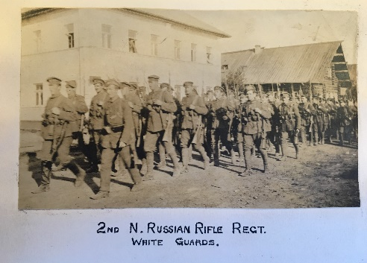
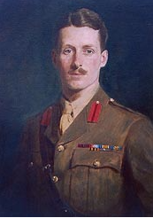
The last time many of us had the opportunity to meet was the FOSIM lunch in November 2019 where Ian Chatfield and I shared the podium to discuss George Roupell’s exploits and the East Surrey’s campaign in North Russia during 1919.
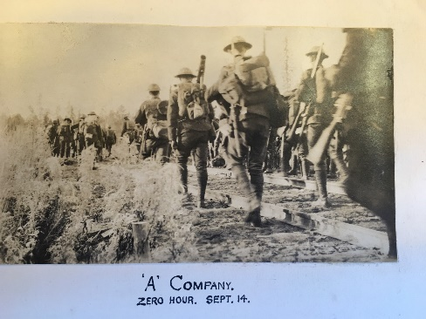
Unfortunately, the lecture lunch scheduled for March 2020 has had to be postponed and the much-anticipated Battlefield Tour to follow the Regiments’ campaining with the BEF in France and Belgium in 1940 is another casualty of the present health crisis.
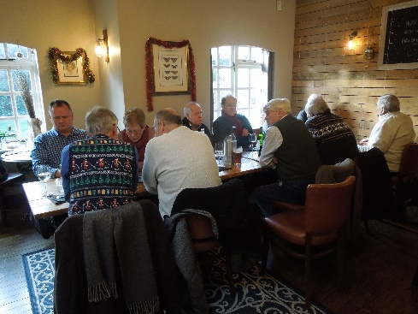
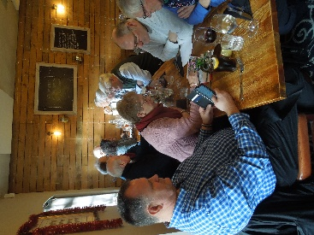
Looking back at happier times, the Volunteers enjoyed a well-attended and deserved Christmas Lunch in December at a local pub-restaurant. My thanks go again to the Volunteers, and Trustees, who continue to support the Museum: their on-going encouragement is much-appreciated.

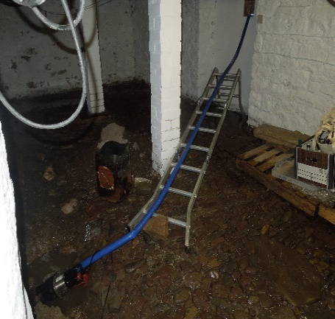
Despite the inconvenience of a flooded cellar during the terrible weather earlier this year, the arrangement whereby I work mainly on-line from home in Shropshire with regular visits to the office in Woking for meetings and to catch up with the Volunteers had been working well. I’d managed one or two trips each month up to the end of February but these forays are currently suspended. However, there is still plenty to be getting on with, especially now that the Trustees have asked me to continue in post beyond my planned retirement at the end of May. This extension is primarily for reasons of continuity and appointing my successor, a process which is necessarily on hold for the moment.
Page 5 Surrey Infantry Museum


Those who were present at my last briefing in November will remember that, on the advice of our legal team, I had been tasked with determining market values for some of the rare or unique items lost in the fire. After many hours trawling the internet and contacting organisations as diverse as auction houses, antique dealers, militaria specialists, the National Football Museum and the official manufacturers of Regimental Standards, I managed to establish market values for most of the items in question: for example, an auction house specialising in sporting memorabilia confidently placed a valuation of £20,000 on the ‘Nevill’ football.
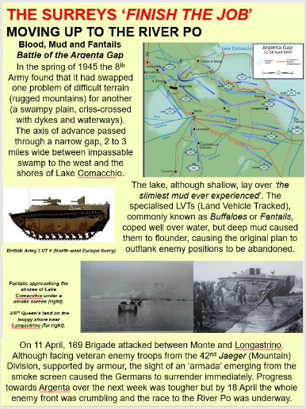
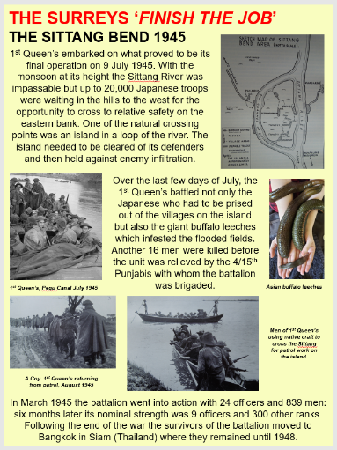
I have also been researching topics and creating display material for our exhibition cabinets in Guildford Museum, including a piece on Regimental symbols, and the story of what the Regiments were doing 75 years ago during the final months of WW2. Under the banner of “The Surrey’s ‘Finish the Job’” I am highlighting the 1945 campaigns in Italy and Burma, possibly less well-known than North-west Europe and the fall of Germany. SIM is also contributing to GM’s main exhibition on the commemoration of VE and VJ Day.
However, at the time of writing we are receiving mixed messages about Guildford Museum’s reopening.
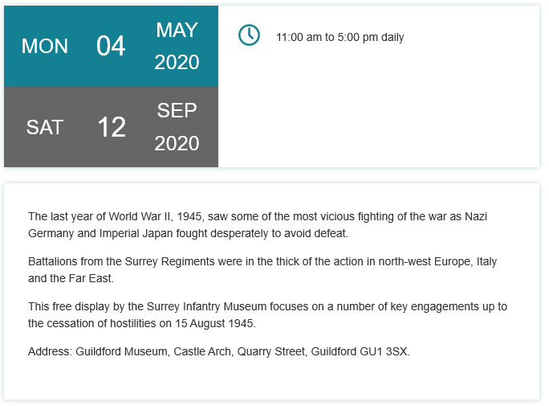
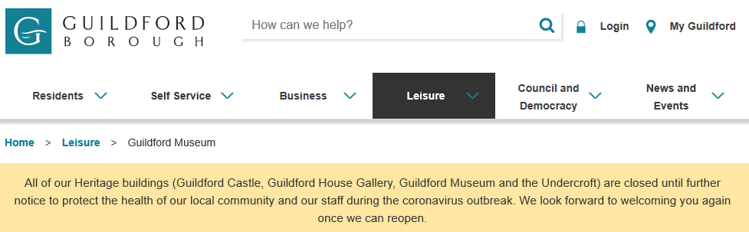
Both these notices can be found on the GBC website but I suspect the target date of 4 May is aspirational rather than achievable.
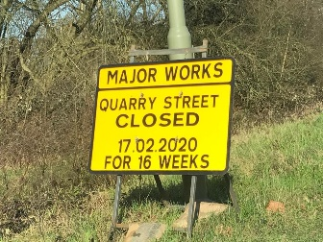
The problem is further compounded by access issues caused by gas main repairs in Quarry Street where the museum is located
Page 6 Surrey Infantry Museum

Given the increasingly lengthy temporary closure of Guildford Museum (re-opening was originally scheduled for June 2019) the SIM Trustees have decided to abandon the idea of moving the SIM office to Guildford before the expansion and refurbishment project is completed. This is to avoid the cost and disruption of moving for what would potentially be a short period of time before having to move out again whilst the main building work is undertaken. All parties are happy for the SIM administration to remain based at the Surrey History Centre until further notice. Progress on GBC’s plans to develop Guildford Museum moves forward slowly: the Council is currently involved in discussions with the National Heritage Lottery Fund regarding its bid for financial support for the project and there should be more news on this over the summer.
Despite the lockdown I’m still finding ways of keeping SIM in the public eye. I subscribe to the monthly magazine Military History Matters which ran an article on the BEF forces trapped at St Valery-en-Caux. Here is the letter published in the latest issue under the headlone of a quotation taken from the Regimental History:

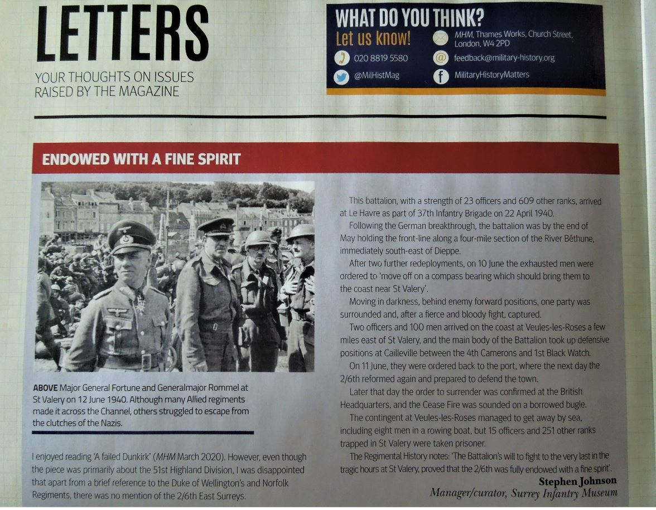
Finally I would like to wish the Volunteers, Trustees and Friends, and their families the best of health over the coming months.
Vel Exuviae Triumphans

Page 7 Surrey Infantry Museum

Out and about - Editor

As we are not doing this very much and the bulk of us following current guidelines thought this postcard was quite poignant!

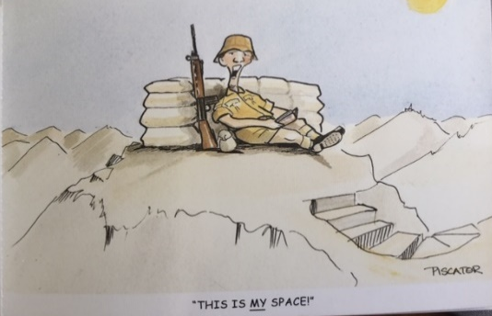

And another conversation came our way on current Militia - Do we still have Militia? and Yes we do in the Royal Monmouthshire Royal Engineers who are the most senior Regiment in the Army Reserve and have been going since 1539.

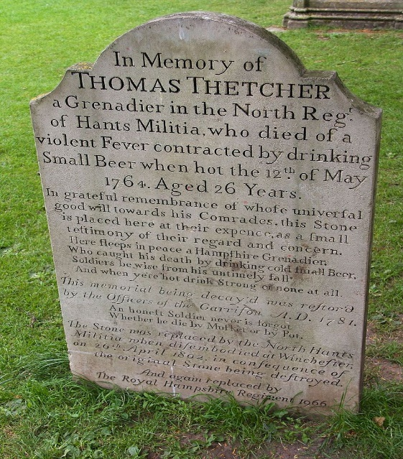
This research went on to find Thomas Thetcher who served in the North Regiment of the Hants Militia as a Grenadier.

I am sure that there is a lesson in here somewhere on not drinking a Small Beer when hot!

The memorial stone at Winchester Cathedral was replaced by the Royal Hampshire Regiment in 1966 and this Militia is a forebear regiment of the PWRR.

Additional reading for the bored at heart!!!

One of our Volunteers is completing his Masters in Military History and advised us of a colleagues dissertation which is on Lt. Col. Hugh John Chevallier Peirs DSO (and 2 Bars) who served in the 8th Bn. Queen's during WW1, commanding the battalion as a Major during the Ludendorff Offensive of 1918, before being wounded full story at http://jackpeirs.org/

Also Bob Hatcher has updated his Malaya website so check it out
https://www.mymalayagallery.co.uk

Page 8 Surrey Infantry Museum

Donations

We are very grateful to receive a monetary donation from Mr Gregory Yap who sadly passed away in 2018. He remembered the Surrey Infantry Museum in his will and we wish to pass our thanks onto his Executors and family. He was a member of FOSIM and came to our very first Battlefield Tour in 2014 and supported the El Alamein Lunch. We will advise what the donation will be used for.

We have also receive on a regular basis smaller sums which we do put to good use. As you can imagine we have a lot of recovery work that needs to be done and the Insurance as you all know does not cover everything. So our thanks is passed to those who have kindly sent donations. All get a letter from Col Ward thanking them for thinking of the Museum.

Lunch Club

GUEST Speaker 2020 – Under advisement but new date Agreed

Our first Guest Speaker of the Year is Sir Nick Young ex CEO British Red Cross. This Lecture lunch will be held at 4 PWRR HQ at Denmark House, Batts Hill, Reigate, RH1 1DS and we thank the RSM Trevor Harrison and Col Jim Bird for allowing us to use the facility.

This a ticketed event so returns are required so we can present a Security Listing as this is an active Unit. If you have previously booked - then new tickets will be sent out once we have the go ahead this event can take place.

Sir Nick Young will be discussing his Book – ‘Escaping with his Life’ and the Story of his father Maj Leslie Young’s WW2 Service. Maj Young served with the Bedford’s originally and then was posted to 1/6th Queens as A Company Commander. Copies of this book will be available for sale at this event published by Pen and Sword.

30th Sep 2020 Sir Nick Young – ex CEO of the British Red Cross £12.50
Escaping with his Life – The story of Maj L Young and his
Exploits in WW2 -Ticket only event.

Page 9 Surrey Infantry Museum

Lunch Club at Surrey History Centre
“meet old and new friends, come to lunch”
Luncheon Club - Proforma

30th Sep 2020 Sir Nick Young – ex CEO of the British Red Cross £12.50
Escaping with his Life – The story of Maj L Young and his
Exploits in WW2 -Ticket only event.
4 PWRR HQ at Denmark House, Batts Hill, Reigate, RH1 1DS

TBC Lt Col (Retd) Peter Swanson £12.50
Gallipoli including the part played by 2nd/4th Queens
Surrey History Centre

Name: -------------------------------------

Email/Address/ Phone if not FOSIM Member:

------------------------------------
In case of short notice cancellation

Cheque amounts enclosed for ----- Tickets Cost £--------------------

Cheques are to be made out to - Queens and PWRR Museum (MM) Fund

Please note you can send separate cheques for each buffet lunch. They will not be cashed until the lunch date is due so can pre date.

Arrive for Pre- lunch Museum update for 12.00pm for lunch at 13.00PM

Guests are welcome to attend and do not have to members of FOSIM.
Please return to:-
Dee Hutchison – Secretary

Surrey Infantry Museum, Surrey History Centre, 130 Goldsworth Road, Woking, Surrey, GU21 6ND

Phone and fax: 01483 770761 email: fosim@btconnect.com

